Nutrition in the news: A visual storytelling assignment

**LifeSci 2N03 assignment #1 (25% of final grade, Part A= 12.5%, Part B= 12.5%)**

**Due: Oct 8 at 11:59pm on Avenue**

**Background:** Everyday, we are bombarded with news and ad campaigns about trendy diets or *super*foods that *claim* to be the miracle solution to our health problems. But, sometimes (and most often!), things aren’t always as they seem. Most Canadians don't bother to investigate what they hear about on the radio, read about on the internet or in the paper, or see on TV prior to starting a diet or buying a health product. Your task will be to locate a written news item published on a main-stream news outlet (*i.e.,* from a news website or online magazine website) about a trendy diet or other fad nutrition-related intervention (*i.e.,* coconut water), critique the news piece, perform additional research on the topic to reach a consensus about the effectiveness of the trendy diet or fad, and communicate your findings of your research in a written summary and infographic.

According to Lankow and colleagues (2012), infographics are graphical depictions of information that use visuals to communicate data, concepts, and ideas to different audiences. Infographics use interesting statistics, easy-to-read and visually appealing fonts, complimentary colours, simple charts and graphs, and other visual aids to translate scientific information in quick and easily digestible format (Shanks, Izumi, Sun, Martin & Shanks, 2017). Creating an infographic also allows the designer to better understand information literacy and practice communicating science and data visualization (Shanks, Izumi, Sun, Martin & Shanks, 2017).

**How to complete the assignment:**

1. This assignment is to be completed individually.
2. Locate a main-stream written news piece about a trendy diet or other fad nutrition-related topic. Look for articles that are published on mainstream news outlet websites (*i.e.,* Huffington Post, Toronto Star, CBC, CNN etc.), on a magazine website (*i.e.,* Men’s Health, Self, Prevention etc.) or other health websites (*i.e.,* BodyBuilding.com). Avoid the less main-stream, scientific websites like Sciencedaily.com or institution websites (*i.e.,* Harvard Nutrition), as these may be more challenging to critique. You can use a hardcopy print version, but you will need to scan or take a photo of the news piece, and the text must be legible.

* The news piece must be about a nutrition-related intervention (*i.e.,* diet, food item, beverage). Please avoid articles about pharmaceutical interventions or natural health products/supplements.
* The news piece should be about how the nutrition-related intervention affects health/disease development.
* The news piece **must** **be based on the findings from, and provide reference to, a scientific study**. For example: randomized controlled trials, observational studies (cross-sectional, longitudinal, retrospective), *in vitro* studies and animal experimental studies, meta-analyses or systematic reviews. Usually, the study is linked to in the body of the news piece, referenced in the news piece or is referenced at the end of the article. **If you are unable to locate the scientific study that the news piece is based on, seek out another news piece.**
* Include a screenshot, or copy and paste the news piece, in the APPENDIX A of your submission.

1. Locate the scientific study that the news piece is based on. Use the single citation matcher in PubMed to help you do this (see APPENDIX for examples). Include a screenshot of the PubMed page for the scientific article in APPENDIX B to demonstrate that you were able to locate it. See the APPENDIX for examples of these screenshots.
2. **PART A (12.5% of final grade):** In a two-page written summary, include:
   * A **brief** background on the topic (*i.e.,* why is the topic important/relevant, how it affects overall health and wellbeing etc.) and nutrition-related intervention. Support your points with references.
   * A description of the message that the mainstream news piece is conveying to the reader.
   * A critique of how well the news piece conveys the results presented by the scientific article.
   * Suggestions about how the news piece could be revised to better portray the message in the scientific article and what additional information the reader should know about the nutrition-related intervention. This additional information could come from the scientific article that the news piece is based on, or other scientific articles on the topic. Be sure to cite your research.
   * References can be listed on a third page.
   * This written piece should be presented as a report of your analysis; it should not be written in first-person (i*.e.,* “I think…”).
3. **PART B (12.5% of final grade):** Transform some components of your written summary into a one-page infographic to convey scientific information about your nutrition-related intervention from Part A. Infographics are commonly used in public health to convey complex messages to the public using visual aids and graphics. Your infographic should be aesthetically pleasing (consider layout, white space, logical flow of content, pictures), eye-catching, contain as few words as possible, and be intended for a non-scientific, lay audience. You do not need to include information about the news article or about your critique of the news article. You may use information from studies that you located for Part A, or other studies not included in Part A. In your infographic, also **include 2 myths/misconceptions about the nutrition-related intervention**. You can come up with these myths on your own based on what you think or what your peers may think about the nutrition-related intervention, and then use scientific literature to debunk the myth.

Here are some additional resources that may help you create your infographic, however you are welcome to find additional resources:

Examples of infographics:

* [A salty situation (Health Canada)](https://www.canada.ca/content/dam/hc-sc/documents/services/publications/food-nutrition/infographic-salty-situation/26-18-2058-Sodium-Infographic-eng-08.pdf)
* [Life is sweet (American Heart Association)](https://www.heart.org/en/healthy-living/healthy-eating/eat-smart/sugar/life-is-sweet-with-these-easy-sugar-swaps-infographic)
* [Choose my plate (USDA)](https://www.choosemyplate.gov/resources/infographics)

Websites to create your infographic:

* [Canva](https://www.canva.com/)
* [Easel.ly](https://www.easel.ly/)
* [Infogr.am](https://infogram.com/)
* [Piktochart](https://piktochart.com/)
* [Venngage](https://venngage.com/)
* [Visme](https://www.visme.co/)

Stock images:

* [Icons8](https://icons8.com/)
* [Istockphoto](https://www.istockphoto.com/)
* [Mochastock](https://www.mochastock.com/)
* [Noun Project](https://thenounproject.com/)
* [PIXLR](https://pixlr.com/)
* [Shutterstock](https://www.shutterstock.com/)
* [Unsplash](https://unsplash.com/)

Design Basics for Infographics

* [13 reasons your brain craves infographics](https://neomam.com/interactive/13reasons/)
* [Neil Patel Infographic Tips](https://neilpatel.com/blog/12-infographic-tips/)
* [7 basics design concepts - Venngage](https://venngage.com/blog/7-essential-rules-create-infographics/)
* [An infographic about making infographics](https://www.easel.ly/blog/how-to-outline-an-infographic/)

**Formatting guidelines:** For Part A and B, use a letter size 8.5x11” page layout. Standard APA formatting should be used for Part A. APA formatting includes: 1 inch margins, double spacing, page numbers, title page, in-text referencing, reference list, headings and sub-headings. Using headings and sub-headings is not mandatory, but may help guide the reader as they evaluate your assignment. No abstract or author note is needed. It is your responsibility to ensure that your assignment meets the APA formatting guidelines. Use the most recent edition of APA. Please visit the OWL Purdue APA website ([OWL Purdue APA formatting](https://owl.purdue.edu/owl/research_and_citation/apa_style/apa_formatting_and_style_guide/general_format.html)) or the McMaster Research Guide on APA formatting ([McMaster Library Guide for APA](https://libguides.mcmaster.ca/APA)).

The only required formatting rule for Part B is to use one letter sized 8.5x11” page and superscript numbers (*i.e.,* example1) to reference scientific literature and images that you use in the infographic. At the bottom of your infographic, include a numbered list of references, using APA reference list style. Your reference list will not necessarily be in alphabetical order but rather in a numbered list according to when the references appear in your infographic.

**Submission instructions:** Please upload 1 PDF containing Part A and B to Avenue to Learn. This will help organize your assignment when it is being evaluated. **If you upload more than 1 document or if the pages are out of order, you will receive a 10% deduction on your final assignment grade.** Your final submission document may include the following: APA formatted title page, Part A page 1, Part A page 2, Part A reference list, Part A Appendix A (screenshot of mainstream news article), Appendix B (screenshot of scientific article in PubMed), Part B infographic. To create 1 document, you can convert the components to PDF and use a PDF combiner like this one: <https://combinepdf.com>

**Deadline:** The assignment must be submitted on Avenue by October 8th at 11:59pm. A 10% per day late deduction will be applied if the assignment is submitted after the deadline.

**Pandemic grace period:** We are all living during a pandemic, and sometimes things happen that may interfere with our ability to meet a deadline on time. In this course, both assignments are worth more than 25%, which means that the MSAF cannot be used. However, a grace period of 3 days for ONE assignment may be used in this course. When you use this grace period, please submit to the corresponding grace period folder on Avenue to Learn so that your assignment will not be graded as late. You do not need to submit any documentation to use this grace period. If you submit to the grace period folder for both assignments, the 10% per day late deduction will apply to one assignment.

**References:**

Lankow J, Ritchie J, Crooks R. Infographics: The Power of Visual Storytelling. Hoboken, NJ: John Wiley & Sons; (2012).

Shanks JD, Izumi B, Sun C, Martin A & Shanks CB. (2017). Teaching undergraduate students to visualize and communicate public health data with infographics. *Front Public Health, 5*, 315, 1-6.

**APPENDIX- EXAMPLES OF HOW TO FIND A PAPER BASED ON A NEWS ARTICLE**

**Example #1 of news piece, showing important information for finding journal article.**

It's time to add probiotic-packed yogurt to your grocery list: The dairy product may help boost your weight loss results, per new research in the *Journal of the American College of Nutrition*. "Probiotics are 'beneficial bacteria' that promote a healthy gut environment and obstruct the growth of 'bad bacteria,'" says Rania Batayneh, M.P.H., author of [*The One One One Diet*](http://theoneoneonediet.com/#sthash.7XpKrM1X.dpbs). "Various studies show they help lower chronic inflammation, improve insulin sensitivity in both diabetic and healthy individuals, and lower cortisol levels, which are key players in belly fat," says Batayneh.

For the study, researchers assigned 75 overweight and obese participants to different eight-week [diet](http://www.womenshealthmag.com/tags/lose-weight?lc=int_mb_1001) groups: regular yogurt/low-calorie diet, probiotic yogurt/low-calorie diet, and probiotic yogurt with a diet that wasn't low-calorie. The participants who ate probiotic yogurt were instructed to eat 200 grams (the equivalent of one cup) per day of a yogurt enhanced with the probiotics Lactobacillus acidophilus, Bifidobacterium, and Lactobacillus casei.

At the end of the eight weeks, researchers discovered that the group that combined the probiotic yogurt and the low-calorie [diet](http://www.womenshealthmag.com/tags/lose-weight?lc=int_mb_1001) saw the largest reduction in both body mass index (BMI) and body fat percentage. They also had lower levels of leptin in their systems. "Leptin is the 'satiety hormone,' and when our levels aren't depleted we are able to better sense satiety and therefore not overeat," says Batayneh. Higher leptin is a common marker of being overweight, write the study authors.

Although the study found a correlation and doesn't prove causation, there's reason to think probiotics had something to do with the results, says Batayneh. "Those who ate regular yogurt were also on a low-calorie [diet](http://www.womenshealthmag.com/tags/lose-weight?lc=int_mb_1001), but the ones who saw the desired effect were consuming probiotics," she says. "It's reasonable to suggest the probiotics were responsible for the results."  A big factor is likely the probiotics' reduction of chronic low-grade inflammation, which is closely associated with obesity, write the researchers. Another reason? You're pairing probiotics with yogurt, which "has protein that can improve insulin sensitivity and increase satiety," says Batayneh.

The specific types of probiotics used in the study are found in most yogurts with the label "live and active cultures," says Batayneh—so double-check your yogurt container, and get snacking!

Reference

Barnes, Z. (2014, August 28). *Eat Yogurt, Lose Weight.* Retrieved from http://www.womenshealthmag.com/weight-loss/eat-yogurt-lose-weight

**To locate the paper…**

1. Go to PubMed via McMaster University library and click on Single Citation Matcher. It is important to type in the journal name or author name correctly and be sure to select the option from the list. If you don't select it from the list, the search will not work out!

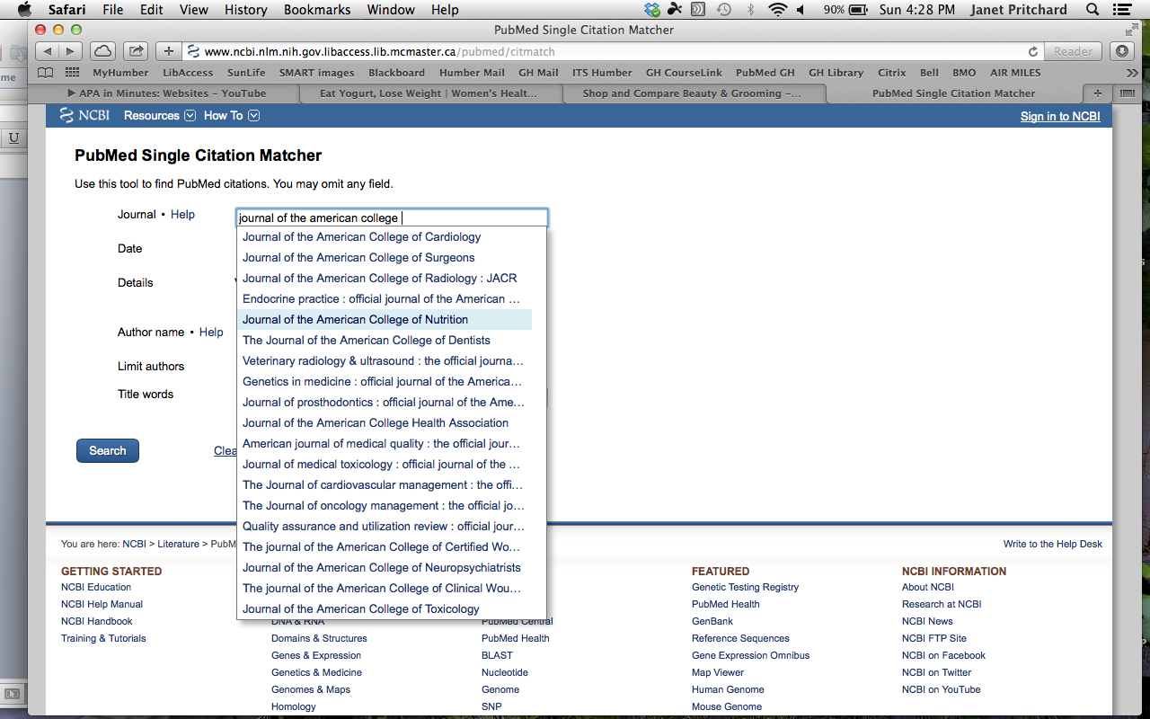



1. Use any information provided for you in the news piece to locate the paper. For this example, the journal name was provided and I used the date: 2014 and title words: yogurt to see if I could find it. Once you locate it, click on one of the download options. I was able to further verify that this was the article that the news piece was based on because in the news piece, the author references the 75 participants included in the study.

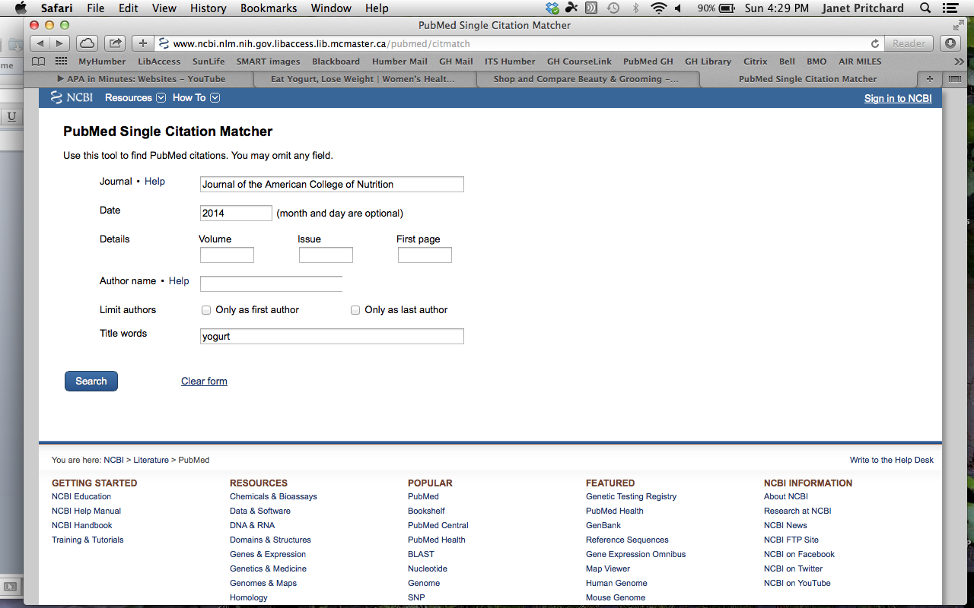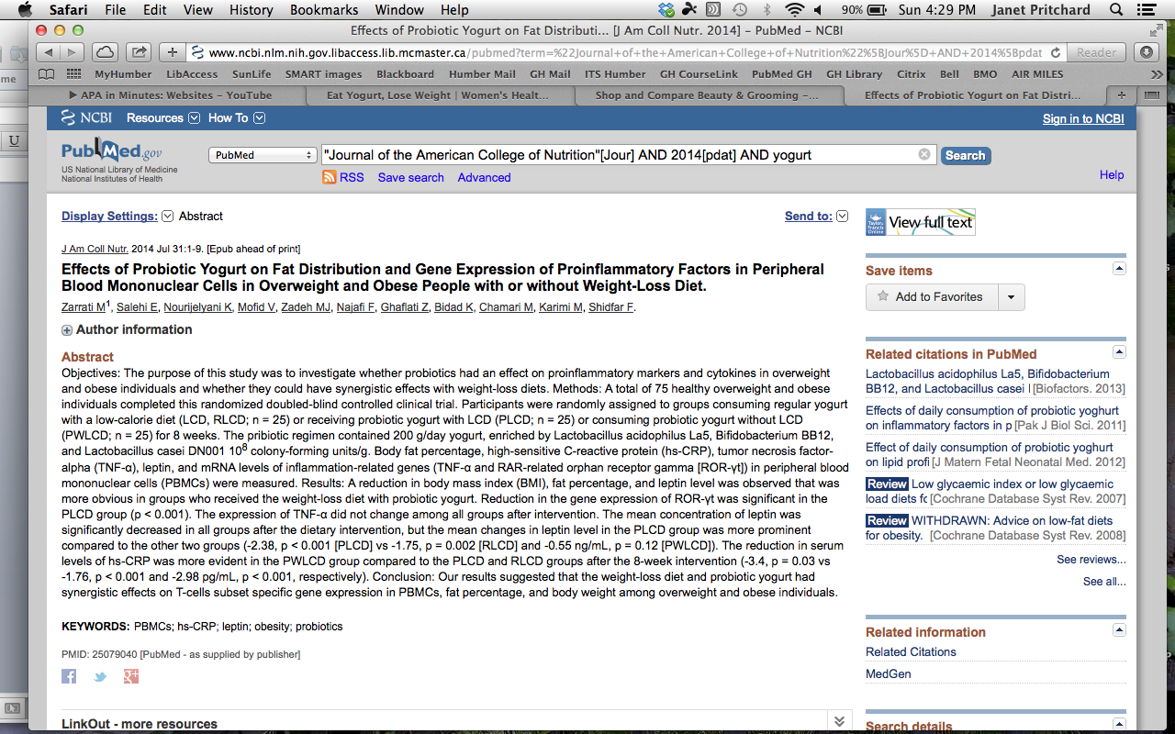

**Example #2 of news piece, showing important information for finding journal article.**

Antibiotic use in early childhood may be a cause of obesity later in life, finds a recent study.

The agricultural industry relies heavily on antibiotics to spur rapid weight gain in livestock animals. So it’s not a total surprise that early exposure to antibiotics like penicillin, could turn out to be a cause of obesity.

Exposure to the antibiotics at a young age alters gut bacteria, which, according to the research published in the journal [Cell](http://www.ncbi.nlm.nih.gov/pubmed/25012772), impacts metabolism and can lead to weight gain regardless of the health of the child’s diet, or his activity level. In particular, penicillin inhibited Lactobacillus, a common bacterium in the gut that’s also common in [fermented foods](http://www.organicauthority.com/10-fermented-foods-you-can-make-at-home) and [probiotics](http://www.organicauthority.com/probiotics-heal-your-gut). The antibiotic also destroyed several other bacteria including Allobaculum and Arthromitus (only present in mice), and a wider group of bacteria called the Rikenellaceae.

“I’m not saying people should never take antibiotics,” says the study’s lead author, Martin Blaser from the NYU Langone Medical Centre. “But we need to be more judicious. Antibiotics can have long-term consequences. I hope that knowledge will enter the examining room, so that parents don’t demand antibiotics and doctors are more cautious about using them.”

The researchers found that just four weeks of antibiotic use was enough to disrupt the microbiome of the test subjects (mice). Even though gut bacteria reverted to its normal state after several weeks, the subjects exposed to the antibiotics were more likely to gain weight. If given the antibiotics in the first month of life, they were 25 percent heavier than control groups and has 60 percent more fat.

“Disrupting the microbiome seemed to exacerbate the effects of a high-fat diet, too, with animals on antibiotics gaining more weight than others who were not given the drugs,” reports [the Guardian](http://www.theguardian.com/science/2014/aug/14/antibiotics-babies-toddlers-obesity-fat). And for unknown reasons, “males put on more weight than females.”

Reference

Ettinger, J. (2014, August 21). *Early Antibiotic Use a Likely Cause of Obesity, Research Finds.* Retrieved from: http://www.organicauthority.com/early-antibiotic-use-a-likely-cause-of-obesity-research-finds/

**To locate the paper…**

1. Go to PubMed via McMaster University library and click on Single Citation Matcher (shown in example #1)
2. Search the authors name and journal.Be sure to select one of the names from the drop down list. If you are not sure of the initial, just select the last name. Hopefully, when you add more information (date or journal or title words), this will weed out the author.

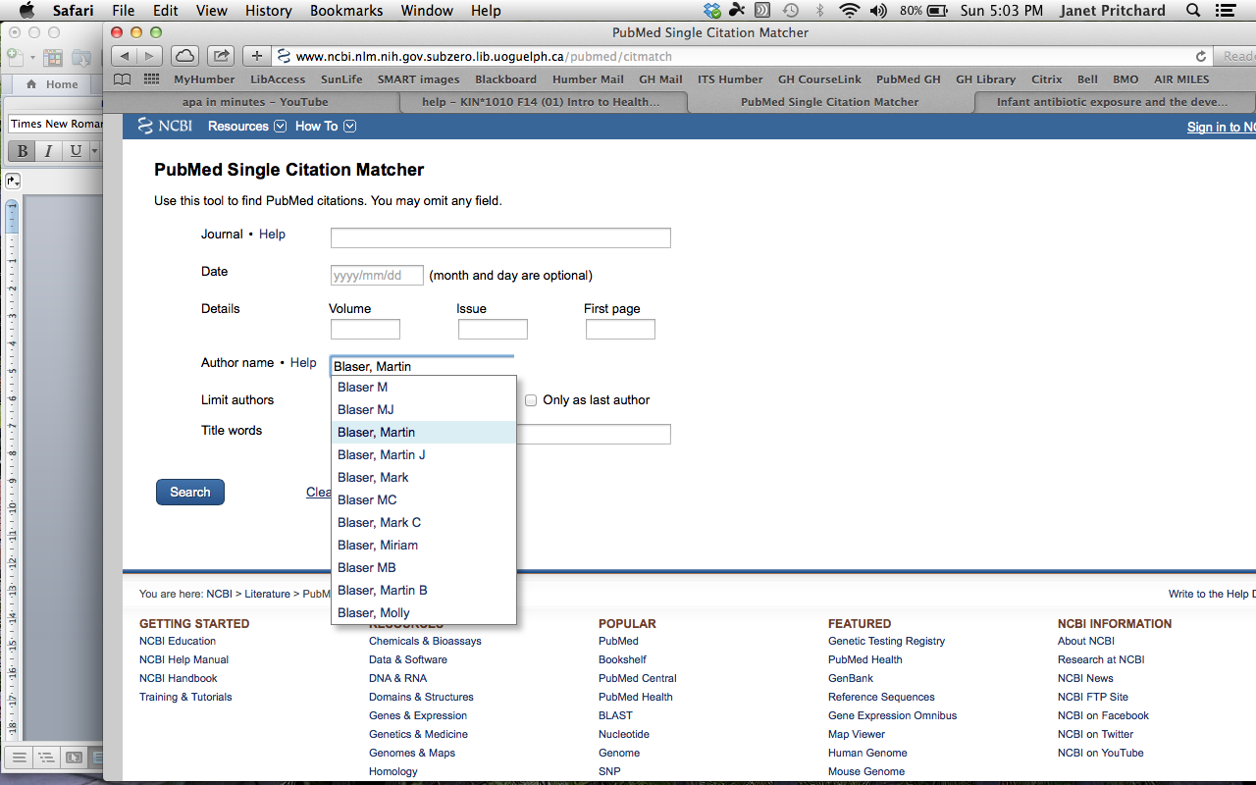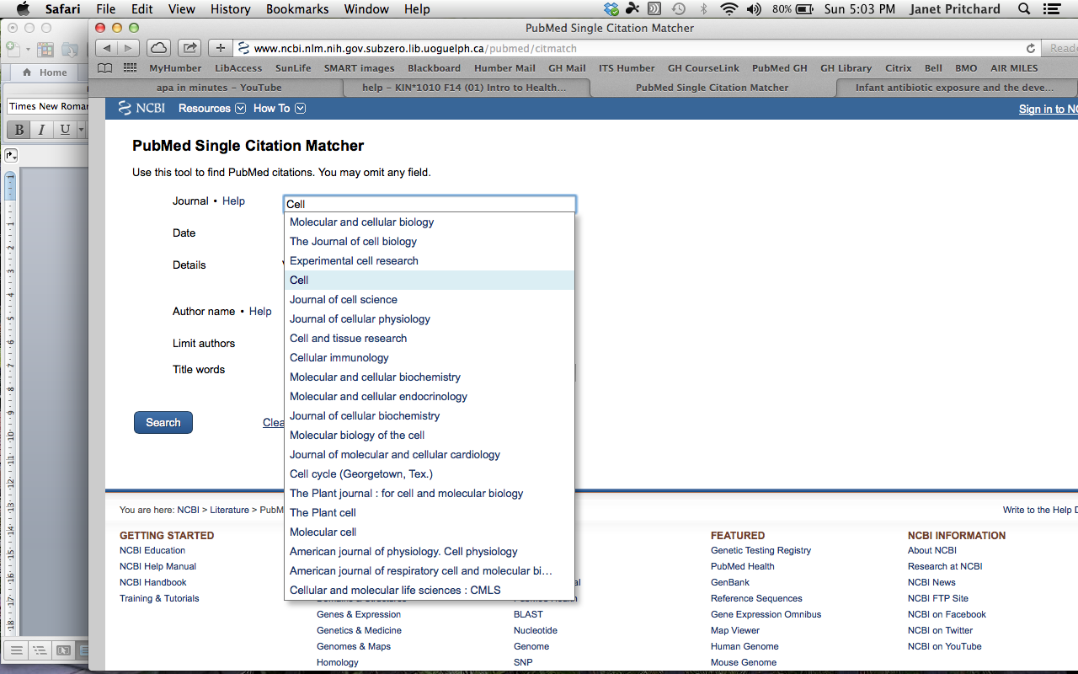

1. Download your paper!

